http://www.extension.umn.edu/distribution/naturalresources/components/DD6946g.html

Stabilizing your Shoreline to Prevent Erosion

What Are Shoreland BMPs?
Best Management Practices (BMPs) are actions you can take to reduce your impact on the environment. BMPs have been described for agriculture, forest management, and construction. This fact sheet describes BMPs you can adopt on your shoreland property to help protect and preserve water quality. In many cases, the best management for shorelands may be retaining the natural characteristics of your property.

Recognizing Erosion Problems
With more shoreline than California, Florida, and Hawaii combined, Minnesota is bound to have areas where shoreland erosion is a problem. It is obvious that wave-pounded properties lose soil and ultimately their value. What is not as obvious is that this erosion process can be accelerated or slowed by the practices you adopt, and that sediment going into the lake or river is a pollutant.
Erosion is a natural process and, therefore, some sediment does end up in surface water. Clearing shoreland vegetation and beach rocks, and increasing runoff to the shore will accelerate shoreland erosion.

Bluff Stabilization
Increased runoff is especially detrimental to high bluffs (Figure 1). Slumping of waterfront bluffs results from unstable soil, usually because surface or ground water is reaching the bluff. On lakes, waves can erode supporting soil at the bottom of the bluff and cause slumping. Along river bluffs, river currents may erode the supporting soil.
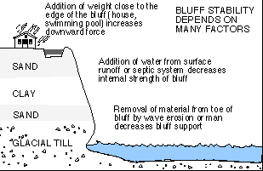
Figure 1: Factors that can make bluffs unstable.
Erosion of higher shoreline bluff areas can be prevented by:
- retaining moisture-absorbing vegetation on the bluff
- outletting rain gutters and diverting surface runoff away from the bluff
- reducing runoff rate toward the bluff
- minimizing paved areas that increase runoff
- limiting ground water flow toward the bluff
- installing septic systems and drainfields away from the bluff
- avoiding additional weight on the bluff edge, such as pools, buildings, or storage sheds
On property with steep slopes or bluffs, reducing the amount of water reaching the bluff will help with stabilization. If diverting water away from the bluff is impractical, it should be routed through a nonperforated plastic drain pipe that outlets at the very bottom of the bluff. Rock should be placed around the outlet to prevent erosion at the bottom of the drain. Surface water and some ground water can be intercepted before it reaches the bluff by installing a "French drain" (Figure 2).
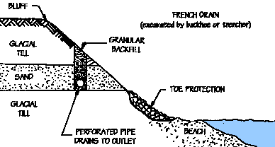
Figure 2: French drains intercept surface water and increase soil stability. Deeper drains will intercept more ground water, but shallower drains are effective also and may cause less disturbance on the bluff. The maximum depth for French drains is 15 to 20 feet.
A French drain is a narrow trench set back from, but parallel to, the top of the bluff and filled with free-draining sand or gravel. A perforated, corrugated plastic pipe at the bottom collects water and should drain away from the bluff. The entire perforated length of pipe must be wrapped with fabric or a filter sock. Installing deeper drains will intercept more ground water and provide better protection for the bluff.
No additional weight such as a building, garage slab, or vehicle should be placed near the top of the bluff. Septic systems and swimming pools are especially inappropriate near the top of a bluff because they add weight and water.
For most property that slopes toward water, leaving the natural shoreland undisturbed is often the best and least expensive protection against erosion. A filter strip of thriving vegetation on and near the shore binds the soil and minimizes soil loss from surface runoff and waves, and from use by people (Figure 3). Existing vegetation can be enhanced by planting woody or aquatic plants.
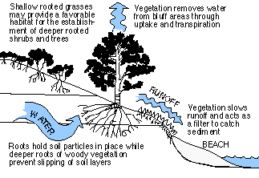
Figure 3: Well-established vegetation on the shore stabilizes the soil and helps remove water.
Natural shoreline features provide natural protection. While swimmers may not enjoy walking on cobblestones, and an ice-pushed ridge may block some of the view from your lawn chair, these features help "nourish" your beach by reducing erosion and trapping sand. Even driftwood absorbs a certain amount of wave energy that otherwise erodes soil.

Shore Protection
Regardless of the natural protection on your shore, the right combination of conditions (such as high lake level and wind direction) can result in a severe wave pounding, and shoreland soil may need additional protection.
Placement of large rock, usually referred to as rip-rap, is the preferred and most common form of shore protection (see Figure 4). Technical methods are available to determine rock size, placement geometry, and elevations to ensure the best protection. Your county Soil and Water Conservation District (SWCD), the MN Board of Water and Soil Resources (BWSR), and the federal Natural Resources Conservation Service (NRCS) can provide technical assistance.
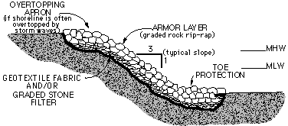
Figure 4: Proper rip-rap placement (MHW=mean high water, MLW=mean low water).
The above agencies will also have information on other types or remedies that may be appropriate for your particular situation. Potential shore protection alternatives include:
- bulkheads (retaining walls)
- gabions (rock-filled wire baskets)
- articulating blocks (cable-connected concrete blocks)
- Geoweb matrix (thick, open-cell plastic grid)
A few of the alternatives can be placed by hand. Some other alternatives, such as railroad ties, are often tried but rarely work. If you have your own idea for a solution, you should seek technical advice first.
If rip-rap is used, crushed or blasted rock locks together better than rounded boulders, but can be very expensive unless it is readily available.
Geotextile fabric is usually placed beneath the rock rip-rap to prevent soil loss through the rip-rap openings. It is easy to place and provides an excellent filter barrier (Figure 4). In order to prevent punctures, plenty of slack should be provided over protruding objects that cannot be removed. A layer of sand or fine gravel can be placed on the fabric for extra protection against puncture. Enough fabric should be laid out so that the rip-rap periphery can be "wrapped" by bringing the fabric up and back down into the rip-rap. This will help hold the rip-rap together as one structural unit. Keep in mind that sunlight will degrade exposed fabric. As an alternative to the fabric, a graded filter layer can be used beneath rip-rap to prevent soil loss through the rip-rap openings.
Sufficient rock must be placed at the base of the rip-rap for toe protection. Excavated toe material must be removed from the lakebed and placed in a non-wetland area.

Costs
The price of rip-rap placement depends on local contractors, distance to the nearest rock source, and access to the project site. It also depends on how much other work, such as clearing or earthwork, is required.
If you are planning to start a project in the mid- to late-1990s, you should expect to pay $40-75 per shoreline foot for inland lake shorelines and $100-175, or more, per foot for Lake Superior shoreline protection. Inquire at the county SWCD office about cost-share assistance.
A project cost can also be estimated by calling earthwork contractors in your area. A big savings can be realized if you can install these items yourself.
If you want to stabilize a slumping bluff, find out about soil types and ground water level. The record from when your well was drilled may be a good information source and can be obtained from the state or county health department or from your well driller. Contact your county SWCD for information on soils.
Effective bluff stabilization will require technical assistance. Request an engineer from the BWSR, SWCD, or NRCS to inspect your site, or consider hiring a geotechnical engineering firm to take soil borings, analyze soil properties, and recommend a remedy. Most private consulting firms can drill 100 feet a day and charge $1,000 a day. For a small site, drilling, analysis, and a recommendation will cost about $2,000 (1996).

